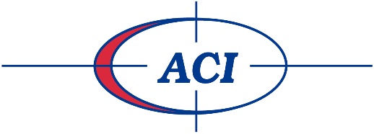
Exceeding Expectations 1Customer at a time, Since 1989

WHo are we?

American Coradius International LLC (ACI) has been a Western New York full-service financial service agency serving national credit grantors in credit card, retail, auto, mortgage and student loans sectors since 1989 with two locations in Amherst and Hamburg.
ACI continues to be a leader in the financial service industry as evidenced by its practice of sound internal controls, advanced collection strategies and continuous quality improvements. ACI is one of the only collection agencies nationally to be ACCREDITED BY THE BETTER BUSINESS BUREAU with a “A+” rating.
We pride ourselves on our integrity, commitment to excellence and drive for success. Our investment in people, products and processes allow us to perform in an efficient and effective manner so that we can remain your employer of choice.
Our team of specialist handle inbound and outbound telephone calls, with a customer service approach and attitude. Building a positive rapport with the customer, while establishing arrangements/resolution to their debt situation that are in the best interest of the customer.

Come experience The ACI difference

At ACI, we understand that our associates are our greatest asset and that is the key to success. The management at ACI understands the importance of a positive work environment and strive to make coming to work not only productive, but enjoyable too. We are looking for individuals who are looking for a career, not just a job.

ACI Gives back
It is a part of our company culture to give back to the community and to the causes that are near and dear to our associates. “We are proud of the commitment and generosity of our employees to these causes!”

Interested in learning more?
Visit our website for more information at: http://www.americancoradiusinternational.com

